The Bus Ticket Booking System is a web and mobile application designed to simplify the

process of booking bus tickets. It allows users to search for available tickets, view detailed information, and book specific seats. The backend is built with Node.js and Express.js, while the frontend uses Flutter for the mobile app and standard web technologies for the web interface. Key features include real-time seat availability updates, filtering options based on travel details, and an administrative panel for managing schedules. The system uses RESTful APIs for all ticket operations, ensuring a smooth and efficient booking process.

1. **Sign in page:**

A page that takes input from user and compare it to the data existing in a json file.

Figure 1 sign in page.

1. **Buses page**

In this page you can do the following.

* Search for specific bus with any/all the following criteria (From city, To city, Date, Time, bus class) (see figure 2)
* Add new tickets using the sliding panel. (see figure 3)
* When clicking on any of the tickets you will be able to book a specific seat on that bus. (see figures 4, 5)

Figure 2 Bus page

Figure 3 adding a bus in the buses screen.

Figure 4 select the specific ticket to book.

Figure 5 example of set of booked seats.

1. **Report page.**

In this page you find a set of helpful statistics with an interactive graph that shows how the sales are going for different buses.

Figure 6 report page.

1. **Profile page.**

Thing is fancy here just a typical profile with data coming from json file, and a picture of a handsome lad.

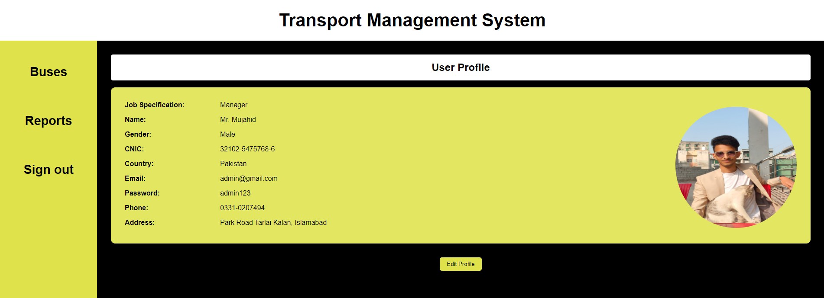

Figure 7 profile page.

1. **End points for the API.**

* Get All Tickets (GET /tickets)

Retrieve all available tickets.

Link: <https://webproject-123-41fb57c20018.herokuapp.com/tickets>

* Get a Specific Ticket by ID (GET /tickets/:id)

Description: Retrieve details of a specific ticket by ID.

Link: <https://webproject-123-41fb57c20018.herokuapp.com/tickets/1>

* Add a New Ticket (POST /tickets)

Description: Add a new ticket to the system.

Link: <https://webproject-123-41fb57c20018.herokuapp.com/tickets>

Message body example:

* Book a Specific Seat on a Ticket (POST /book-seat)

Link: <https://webproject-123-41fb57c20018.herokuapp.com/book-seat>

Message body example:

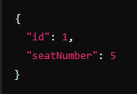

1. **Mobile app (User side)**

The supposedly user application to book a ticket.

Figure 8 application interface.